May 12th 2017
St Augustine’s Junior 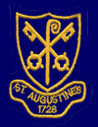

A Message From Mrs Pierce
A huge well done to our wonderful Year 6 who have survived a week of tests! Every child worked their socks off and really persevered throughout.

We celebrated with a trip to the park and ice lollies yesterday – and a bacon/ sausage roll for breakfast this morning. We are very proud of you all.

We are looking forward to welcoming Grandparents/ Special People into school next Tuesday (16th May) to spend the morning with us. A buffet picnic lunch will be provided for those who have requested lunch so let’s all pray for sunshine!

Wishing Miss Wilkinson well!
As you may already be aware, Miss Wilkinson was taken ill this week and is currently in hospital undergoing tests. I’m sure you will join us in wishing Miss Wilkinson a speedy recovery. The Upper School team will ensure that there is continuity and consistency in the provision for Glennie class in her absence.

Spelling Bee Sponsorship
After the success of our Spelling Bee last week, can we please remind you that sponsorship money should be brought into school by Friday 19th May 2017.

Book Fair
We will be holding our annual book fair again next week from Tuesday 16th-Friday 19th. The book fair will take place in the new hall and will be open before and after school. There will be a wide selection of books and stationery to choose from for all ages. As it is Grandparents day on Tuesday, we plan to open the book fair over lunchtime so they too can have a browse through the selection of books.

We will also be giving all the children the chance to visit the book fair during the school day on Thursday 18th. If you would like your child to purchase a book, please send money in with your child in a named envelope on Thursday morning.
This has always been an extremely successful event as a percentage of book sales are awarded to our school as tokens for every purchase made so we would love to see as many of you as possible supporting the event.

Book Bus Fundraiser – Children’s Bingo – Thursday 29th June 3.00-4.30pm
As a school we are fundraising to have a library bus on the school premises. Last term, we hosted a very successful quiz night for parents and carers and raised nearly £800 towards the cause. This term, we are arranging bingo for the children so that your child can be involved in the fundraising effort whilst having lots of fun. We will be selling tickets for this event after the May half-term (a letter will be sent home with your child in due course)- tickets will be £2.00 per child (with unlimited squash) and there will be a tuck shop on the day. There will be many prizes on offer and should be a fantastic event. Please put the date in your diary!

Year 3 Rand Farm Residential Trip
Medical forms and kit lists have now been distributed; please ensure that the medical forms are completed and returned to school prior to the parent’s information evening on the 18th May.

Trainers at lunchtime
As the fair weather settles in, we would encourage all children to bring in spare trainers for morning and lunchtime breaks. All children must change their footwear in school to trainers if they wish to play on the trim trail, tyre park or the climbing frame.

Lunchtime Menu
The dinner menu next week is Week 2:

MONDAY | TUESDAY | WEDNESDAY | THURSDAY | FRIDAY
Pork Grill in a Bun | Grandparents’ Day - Picnic Lunch | BBQ Chicken with Rice | Roast Chicken Breast Fillet, Stuffing & Gravy with Roast Potatoes | Salmon Bites & Chips
Quorn Grill in a Bun |  | Bean & Vegetable Bake with Herby Diced Potatoes | Quorn Fillet, Stuffing, Roast Potatoes & Gravy | Pasta Neapolitan
Jacket Potato & Baked Beans |  | Ham Salad Baguette | Cheese Salad Wrap | Jacket Potato & Cheese & Coleslaw

Calendar Dates
Tues 16th May – Grandparents’ Morning
Tues 16th May – Fri 19th May – Book Fair
Thurs 18th May – Murray Class Worship
Thurs 18th May – Rand Farm Parents Information Evening
Mon 22nd May – Yr6 Trip to Peterborough Cathedral
Mon 29th May – Fri 2nd June – HALF TERM

Awards

Stars of the Week
Every week, each class teacher nominates a child who has been a wonderful example to others through their effort, attitude to learning, their behaviour or kindness.

This week‛s winners are: Darren, Aleksa, Harry, Kieron, Jake, Matthew, Jade, Casey, Ollie and Arina

Attendance Award
This week’s winner of our attendance award is a very well deserving Farah Class with an impressive 100% attendance. Keep up the good work!
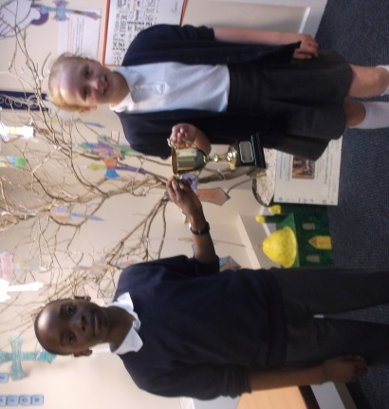
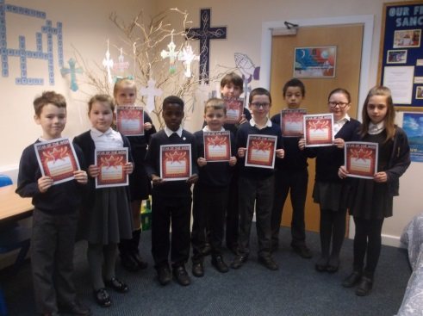

Attendance Award Stars of the Week
Top 4
A big “well done” to the following children who earned the most House points in their class this week.

Murray Class – Darren, Emily, Leo, Emilija
House Point Totals
St John 1096 St Mark 1151 St Luke 1082 St Peter 1011
Ross Class – Joshua, Sienna, Patrycja, Aleksa
Welby Class – Neave, Mia, Rosie, Tife
Simmonds Class – Chris, Evie, Florentina, Oliver
Attenborough Class –
Glennie Class – Jade, Evita, Mustafa, Maddie
Newton Class – Shea, Theo, Julia, Samuel
Farah Class –

