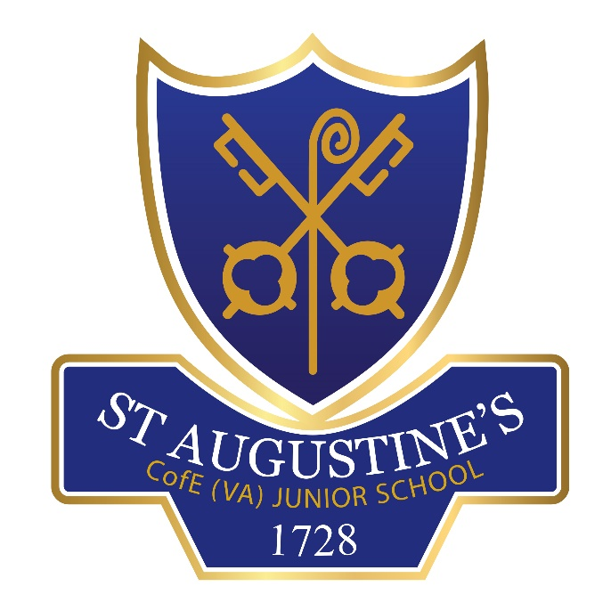
RE POLICY
ST. AUGUSTINE’S C of E (VA) JUNIOR SCHOOL

Headteacher (Sam Brunt) | Signature  S Brunt
Chair of Govs  (Peter Ananicz) | Signature  P Ananicz

Date ratified: 16.10.23
Review date: Autumn 2025

Introduction
RE in VA Church of England Schools is the particular responsibility of the governing body; governors should agree the RE Syllabus and policy, and monitor provision in their school. The Diocese of Ely has provided our school with a syllabus for The Emmanuel Project that will be taught alongside the County Agreed Syllabus.
Pupils who follow our RE programme in our school will gain a deep awareness of their own and others’ identities; they wrestle with the mysteries of life and the answers given by a wide variety of religions and beliefs; they develop a clear sense of what is of real value in world today.
Our aims of Religious Education
- To enable pupils to encounter Christianity as the religion that shaped British culture and heritage and influences the lives of millions of people today
- To enable pupils to learn about the other major religions, their impact on culture and politics, art and history, and on the lives of their adherents
- To develop understanding of religious faith as the search for and expression of truth
- To contribute to the development of pupils own spiritual/philosophical convictions, exploring and enriching their own faith and beliefs.
Our outcomes for pupils at the end of their learning journey of our school:
We aim that our children will:
- Think theologically and explore ultimate questions
- Reflect critically on the truth claims of Christian beliefs
- Develop skills to analyse, interpret and apply the Bible text
- Recognise that faith is a particular way of understanding and responding to God and the world.
- Analyse and explain the varied nature and traditions of the Christian community
- Make a well-informed response to Christianity
- Respect those of all faiths in their search for God
- Reflect critically on areas of shared belief and practice between different faiths
- Enrich and expand their understanding of truth
- Reflect critically and express their views on human quest and destiny

Teaching and Learning about Christianity
At St Augustine’s Junior School, we use the Emmanuel Project which has been developed by Suffolk Diocese in conjunction with Ely Diocese to develop a well-rounded curriculum that covers all major world faiths.
The Emmanuel Project’s approach to teaching about world religions and world views builds upon pupils’ encounters with religious texts and stories. Pupils begin by exploring basic stories before building to analysing text for the purpose and significance it holds for believers. Pupils then progress to look at practice and community living with a good grasp of the theological concept being explored.

Aims of The Emmanuel Project
- To enable pupils to know about and understand Christianity as a living world faith, by exploring core theological concepts
- To enable pupils to develop knowledge and skills in making sense of biblical texts and understanding their impact in the lives of Christians and other faiths.
- To develop pupil’s abilities to connect, critically reflect upon, evaluate and apply their learning to their own growing understanding of religion and belief (particularly Christianity) of themselves, the world and human experience.
Teaching and learning about other faiths and world views
Our school has a duty to foster an accurate and increasing understanding of world religions and world views. As a result, our pupils will gain greater insight into the world in which they are growing up. They will also be able to appreciate the faith of others and develop a deeper understanding of their own beliefs and practices. These outcomes must contribute to harmonious relationships within and between communities, promoting social inclusion and combating prejudice.
Experiences:
- Interfaith participation
- Interfaith weeks
- Visitors from world faiths
- Visits to places of worship
Assessment
During the units of study, there will be flexible opportunities for assessment, aiming towards end of phase/key stage outcomes that incorporate knowledge and skills that which to handle, integrate and apply this knowledge but allowing pupils to make progress from simple surface learning to deeper learning at all ages in our school. Assessments will take place by using quizzes, Solo Taxonomy and other various ways to assess knowledge.
Curriculum Balance
Christianity will be an equal balance to other faiths of the world.
- 50 percent Christianity
- 50 percent will be other faiths
- At least 1 hour per week
Subject Leader Role and Professional Development
- To drive improvements in RE by annual action planning and monitoring of the subject
- To review and update the RE policy and scheme of work regularly, in line with statutory guidance from the Agreed RE Syllabus
- To implement the school’s RE policy and scheme of work, ensuring that an engaging, high-quality RE curriculum is being delivered throughout the school
- To monitor and evaluate teaching and learning, planning, and pupils’ work in RE
- To feedback to SLT & Governors to inform the SEF & SDP where appropriate.
- To ensure that the teaching of RE is fully inclusive
- To keep up-to-date with, and enable other members of staff to be aware of, any new developments relating to this curriculum area
- To attend appropriate courses that will enhance the Subject Leader's role and RE in the school generally, as well as informing other staff of INSET opportunities and arranging/delivering INSET within the school
- To extend and update resources as and when necessary, in line with the school's budget arrangements and ensure resources are accessible and well maintained
- To provide and organise a range of enrichment opportunities in RE, including out-of-school trips and experiences
- Staff will be encouraged to attend courses to further their understanding of teaching RE

Resources:
The religious education resources are ever changing and our plans can be found on a shared google account as well as in co-ordinators folder.

- https://www.cofesuffolk.org/schools/school-leaders/religious-education/emmanuelproject/
- Long term plans
- Mid-term plans
- RE online website
- Artefacts
- www.ely.anglican.org/education
Monitoring and Reviewing
Leader of RE will monitor teaching and learning by observing, discussions, staff meetings and book-looks to ensure consistency throughout the development of Religious Education skills and levels of understanding throughout the school. This will give the leader and opportunity to analyse and report progression in Religious Education.
The leader will:
∙ support colleagues in their teaching and planning
∙ use specially allocated management time to monitor RE across the school.
The quality of teaching and learning in RE is monitored and evaluated by the RE leader, head teacher and governors.
Religious Education and the Wider Curriculum
There are clear links between Religious Education and other areas of the curriculum and our core values are reflected in all areas. Work in our Religious Education gives strong support to work in literacy, British Values, PSHE and ICT. SMSC development is closely linked to Religious Education too.
Religious Education and Collective Worship
Religious Education is a main core purpose of the school. Collective worship will often make links to studies of Religious Education; however this will not replace the learning that takes place in the classroom. By making links, the children will deepen their understanding of what is being taught in the classroom. The Core Concepts that will be integrated will include: God, Creation, Fall, People of God, Incarnation (Holy Trinity), Gospel, Salvation, and Kingdom of God (See Collective Worship Policy).
Inclusion
In planning for and organising RE activities, teachers take a differentiated approach to ensure equality of opportunity for all children, including those with SEN, EAL, those who are and those from all religious and cultural backgrounds.
Right of Withdrawal
Parents have the right to request that their children are withdrawn from all or any part of Religious Education. This right is rarely exercised and for this reason it is expected that, if such a request is being considered, the parents will make an appointment to discuss their concerns with the Head teacher before making a final decision which should be notified to the school in writing.
Any child who is withdrawn from Religious Education lessons should still be supervised and provision should be made, wherever possible for him/her to work separately from the class. Where appropriate, parents of pupils withdrawn from Religious Education are encouraged to provide suitable material relating to their own beliefs for their child to study during that time. Where this does not happen the child will be expected to continue with an aspect of their learning provided by the class teacher. A statement about the parental right of withdrawal is included in the St Augustine’s School brochure to fulfil the legal requirement. There will be occasions when spontaneous enquiries made by pupils on religious matters arise in other areas of the curriculum. Circumstances will vary, but responses to such enquiries are unlikely to constitute Religious Education within the meaning of the legislation and a parent would not be able to insist on a child being withdrawn every time issues relating to religion and spiritual values are raised.
Teachers, including the head teacher, similarly have the right to withdraw from teaching Religious Education. Any colleague who feels that they are unable to carry out their professional responsibilities with regard to Religious Education because of their own religious beliefs should discuss this with the head teacher. In case of the head teacher exercising the right of withdrawal, it is the responsibility of the Governing Body to ensure continuity of provision of Religious Education in school.
(See Section 3.1 Religious Education in Schools (England) page 19

